Workers hanging in between hometown and city amid covid19

Table of Contents
- Introduction 2
2. Executive summary 7
3. Methodology 17
4. Indicators of migrant worker’s vulnerability 21
Social marginalization of the workers 21
Occupational insecurity of the migrant workers 22
5. Impact of the sudden and unplanned lockdown on the lives migrant workers 24
Worker are rendered jobless 25
Migrant worker have turned in completely cashless 26
Non Payment of due wages to the workers 28
Cut down in the household expenditure to adjust the loss 30
The occurance of emergency situation in the lives of migrant workers 31
6. Access to the essentials items and support received by the migrant workers during lockdown period 34
The in-availability of adequate ration to the migrant workers 34
Negligence of the migrant workers for the financial support 35
Borrowings by the migrant workers for the essentials needs 37
7. Workers strategy to deal with the current emergency 40
Workers want to return back to the city for work 40
Survival options until they return to the city 42
Workers are relying on the support of their social network more than the govt 44
Support and assistance sought by the workers 45
8. Case studies 48
9. Conclusion 55
10. Annexure 58

Introduction
The current humanitarian crisis in the lives of the migrant worker in the country in the wake of covid19 has assumed huge importance recently in quite a few months. However, the point that needs to be emphasized here is that this is a good opportunity to highlight the contributions of migrant workers and the survival struggle they face in the city which often remain invisible.
The migrant workers are the ones who travel to and fro from the rural areas in search of livelihood and largely belong to the states with a poor economy. The estimated number of migrant workers in the country is about 100 million (Deshingkar and Akter, 2009.)and some other estimates suggest the number even more than this. The migrant worker largely belongs to the socially marginalized community and thus form a very vulnerable group. The majority of migrant workers are unskilled or semi-skilled who are employed in the construction work, textile industry, domestic work, home-based work hotel & restaurant, casual labor, etc, and work without the formal contract. However, the majority of migrant workers are the part of the informal sector which pushes them to the edge of uncertainty.
The informal workers are also known as “wage hunter & gatherers and footloose workers” (Economic and Political Weekly, 2020)in the words of Jan Breman who constitute about 93%(Labour Bureau Govt of India 2013-14) of the total workforce in the country. About two-thirds of the total informal workers do not even receive minimum wages and this is the case especially with the interstate migrant workers(Economic and Political Weekly 2020) in the country. The recent legislation of labor code is another new condition that has thwarted the protection net of workers by removing all the protective legislation of the past. Other than this the migrant workers have no proper access to public housing, civic amenities(Desai 2020), food security in the cities and many acts related to their protection have become obsolete or are not implemented properly(News Click 2020). However, the circumstances for the migrant workers were already very tough when the lockdown was announced in the wake of covid19 pandemic which proved to be a fuel in the existing fire.
The lockdown period has put up several challenges of survival for the migrant workers across the country. The migrants have faced a severe form of hunger, work loss, non-payment of wages, deaths due to starvation, fatal accidents, etc. During the lockdown, however, the migrant workers were stripped of all their rights and the govt has succumbed to protect them resulting in the great humanitarian crisis in the country.
It has been more than four months of the lockdown and the govt has estimated that about 67 lac migrant workers have returned to their home(The Indian Express 2020) so far based on their latest estimation.However, a huge chunk of the migrant population has returned home in the wake of pandemic outbreak in the country.
Given this situation of the migrant workers in the country, the govt has claimed to provide many relief packages to the poor but it could not reach the needy migrant workers adequately.
An estimation by a network called SWAN tells that about 82% of migrant workers have not received any govt ration and 70% of them have not received any cooked food. The estimation of SWAN was based on a survey of more than 5000 migrant workers across the country (SWAN 2020). Piyush Goyal a union minister of Railways has made a statement in the month of May that “we have gone through the entire three months without single person starving. That is not just the efforts of central or state govt It is the efforts of 130 crores Indians” The statement itself proves the fact that the response of the govt to worker’s crisis was grossly inadequate. Gaps and irregularity in executing the relief packages also testify that there was a lack of coordination between state and the central govt and political differences might have played its role too.
However, the question that needs to be addressed at this point is that how did the huge population of migrant workers returning home cope up with the emergency without any adequate support provided by the govt? In parallel to this, another question that arises here is that in the absence of regular work and adequate resources how the migrant workers will face the post COVID scenario as the pandemic has completely altered the livelihood pattern in the country?
Therefore, in this context, a need was felt to conduct a study to map the situation of migrant workers affected due to the covid19 in the country. The main idea behind conducting this study was to understand the coping mechanism of the migrant workers during the pandemic time in the absence of adequate support and resources and what is their strategy for the future to deal with the given situation?
The present study is based on the telephonic survey of 426 migrant workers from the five tribal districts, Sirohi, Udaipur, Dungarpur, PratapGarh and Pindawara of the state of Rajasthan who has been working in the different parts of the country.
It is quite evident that the lockdown has left the migrant workers into a severe distress condition compelling them to evolve their own strategy to cope up with this situation. However, to deal with the current survival crisis the migrant workers have adopted several methods to overcome the distress situation which includes borrowing in cash or kind and seeking support through their social network in their hometown. The biggest insecurity that has come from the worker side is that they might not be able to stay in their villages for a long time, however, they have to ultimately return to the city.
To meet the essential requirements during the lockdown, therefore, 48% of workers have reported borrowing in cash or kind with 59% of the total worker taking the credit of rupees 600-3000. The other 9% of workers claim to take the credit amount of 4000-5000 while the 6% worker has taken an amount of more than 9000 rupees. The amount of money taken on credit by the workers are huge in relation to their earning which is very low. The amount of money borrowed here is from the time of the second phase of the lockdown when the survey was conducted. We can just imagine how drastic the situation would have become now.
The social capital of the migrant workers in their hometown is very strong compare to the city which works as a good support system for the workers when they are in the distress condition. About 45% of workers in the present study directly rely on their social networks to face the current survival crisis. To secure work in the nearby or to borrow cash or in-kind the workers are of the opinion that their friends, family, relatives can be more useful than the govt. The other 26% of workers look to Gram Panchayat and 7% to the welfare organization for the support to overcome the current crisis.
As it is hinted earlier, despite all these methods adopted by the workers, the workers can't rely on these support systems forever. However, the workers are of the opinion that they are bound to return back to the city again for the work on the opening of the lockdown even if the danger of the virus still prevails in the city. In the present study, about 69% of workers claim to return to the city for the work as the village does not have that capacity to accommodate the work requirements of the workers for the longer-term. To return back to the city about 37% of workers demand a safety kit( Masks, Sanitizers, Globs, etc)while the other 24% workers are in that desperate situation that they don’t demand anything from the govt to return back and claims to take care on their own. However, the desperation of the migrant workers has reached its final stage forcing them to take the extreme steps.
The migrant workers are currently in a great distress situation given the condition of work loss, unavailability of resources, etc and therefore they are in desperate need of support from the govt to overcome this. However, about 52% of migrant workers demand to get a local level work available for them for a short while with 38% of workers in the favour of work with local wage rates in their hometown. When it comes to the work at the local level about 20% of workers prefer for NREGA while the other 17% want the work available nearby their villages. The wage rate that the workers demand for the local work is 300-400 rupees by 37% workers which are about equal to the minimum wage rate in the country. On the other hand, 31%workers are ready to work on the wage rate of 200-300 rupees which is very less from the minimum wage rate. However, the workers are in desperate need of the work and therefore are ready to even compromise with their minimum wage rate if the work is locally made available to them.
Along with this, the workers are looking to the govt and welfare organization to get support in acquiring the new skills, financial assistance for opening up self-employment in the village and assistance for the farming which will help them reduce the current distress. Also, a lot of migrant families have reported to undergo a heavy debt due to the lockdown and seek support for this.
The shock of covid19 however has put the migrant workers belonging to the historically marginalized community of ST in a very distressful condition. The methods such as borrowing and seeking support from their social network etc are not sustainable for protecting the workers for a longer period of time. Hence a majority of migrant workers want to return back to the city without thinking of their safety in the city. However, the workers are crying out very loud for support in terms of work opportunities and financial support.
We are presenting the findings of the study with a hope that it will be useful in locating the crisis of the migrant workers belonging to the historically marginalized community due to the shock of covid19 in the country and help find a solution for the same at the various level.

Executive summary
Indicators of vulnerability for migrant workers:

- The migrant workers are surrounded by multiple vulnerabilities like big size of family, unsecured income, families dominated by only one working members in the paid employment, etc --In the survey, it was found that about 83% of the total workers family has a size of 4-8 family members. The survey has also brought the fact that most of the workers are daily wagers which constitute about 54% of the total survey and rest receives the payment after the completion of every month. The daily wager is more vulnerable than the salaried workers because they are dependent on everyday earning for their ends to meet. About 74% of the worker's families have only one member in paid employment and further 75% of the workers claim that no other members in the family were working at the time of lockdown.

Impact of the lockdown on workers:

- Workers were rendered completely jobless during the lockdown -One of the very important facts that the survey has brought to the notice is that workers were without regular work for a large number of days due to lockdown. The work loss for the workers stretches between 1day to more than 99 days after the imposition of the lockdown in the country. About 82% of the total workers surveyed claim to have no access to the regular work for about 29-56 days.

- The lockdown has left the migrant workers cashless - The present study has pointed out that about 5% of the total workers turned in completely cashless when the sudden lockdown was announced by the govt and about 54% of them have only the cash of rupees 100-3000. When the second phase of the lockdown was drawing to an end in April, about 57% of workers have reported that they had no money left at all and 22% of the reports to have just rupees 100-500 left in their hands.

- Migrant workers have ended up their payment getting stuck to their employees due to the sudden lockdown- As the lockdown was imposed suddenly many workers have ended up having their payment got stuck to their employees. In the current survey, about 30% of the workers have claimed to have their payment stuck to the employees. The pending wage amount varies anywhere between 500 to above 50k which includes for both types of workers the daily wagers and the ones who receive the payment on completion of every month. It was found in the survey that about 36% of the total workers who have their wage pending has an amount between 1100-3000 rupees and the other 27% between 9000-30000 rupees.

- The incidents of the emergency situation in the lives of workers and the absence of support from the govt. - In the present study, about 10% of workers have reported having an emergency situation during the lockdown but they seem to have received very little or no support from govt in handling it. Of the total emergency situation that occurred in the lives of workers, just about 19% of them have got the treatment from the govt hospitals.

- In the absence of regular work and adequate support, workers were compelled to cut down their daily expenses on foods and essentials- In the survey, It was found that in absence of having adequate resources to support the essential needs of the family, about 92% of the workers have cut down their household expenditure to adjust to the loss, which occurred due to sudden lockdown. Out of the total cut downs, about 55% of them are in the category of nutritional intakes, food & vegetable, 21% in the ration & essential items, and 9% in per day meals intakes.

- Workers had no sufficient ration to survive during the lockdown- In the survey, 33% of workers reported that they did not have PDS ration accessible during the lockdown.

Support reached to the workers during the lockdown:

- Workers were denied adequate financial support during the lockdown- About 38% of the total workers report having received no help from the govt in terms of food and ration during the lockdown period. When the workers were asked about receiving any financial help from the govt about 44% of the reports to have not received any financial help. And those who claim to have received the financial help, have got very little amount which will not be sufficient at all to take care of all the essential needs of their large family. Out of the total workers who received the help about 34% of workers have received an amount of just 500 rupees, 19% of the 1000 rupees and 12% have received 1500 rupees only. Other than the govt. about 91% of the workers have reported receiving no help whatsoever from any other organization so far.

- Lockdown forced the migrant workers to borrow for the essentials needs - In the survey, it was found that about 48% of the workers have borrowed from other people in cash or kind to meet their essential needs. Out of the total workers who have borrowed, about more than 59% of them have borrowed an amount between rupees 600-3000, 9% of them borrowed an amount between rupees 4000-5000, and 6% have borrowed more than 90000 rupees.

Workers strategy to cope up with the challenges posed by lockdown:

- In the absence of regular work and adequate support, workers were left with no option but to take a risk for work by returning to the city -In the survey, it was reported that about 69% of the total workers want to get back to their work after the lockdown gets over or after staying at home for a while. Eventually, for a safe return to the work, about 37% of workers demands for the safety kits like a mask, sanitize-rs, globs, etc and 24% of them claims to protect themselves on their own to return to their works.

- To survive in the meanwhile time until the workers return to the city for work, workers are demanding for local-level work temporarily- About 52% of the total workers in the survey want to work at the local level meanwhile and 16% of the other workers tell that they want to return to the city in a short while. As a result, about 38% of the total workers want to get the work made available locally on the local wages when they were asked about their work plan till they return to their earlier works in cities. The other 20% of the total workers sided with NREGA, while 17% of them wanted the work in their nearby village. When asked about the wage rate expected to work locally 37% of the total workers expect a wage between 300-400 rupees and the 31% expected an amount between 200-300 rupees.

- Workers are relying more on their social network for the support in the current emergency than the govt- To overcome the distressful full situation the workers are already trying many ways such as borrowing and cutting down household expenditure etc. When the workers were asked about how they will deal with the current emergency, about 45% of them have told that they will use their social networks such as family, relatives, friends, etc for the support. The other 26 % and 7% of workers are looking to the Gram Panchayat or the govt and welfare organizations respectively to get supported in this difficult situation.

- Workers demands for the financial support and skill-based training to fight the current crisis- When the distress migrant workers were asked about their requirement of support, in the survey about 28% of them asked for the new skill-based training, 9% of them wanted financial help to get a self-employment business started and 5% of them asked support for farming in the village. In the category of others which constitute about 37% of the total responses, about 33% of the total workers claim that their family condition is very miserable and they need immediate support for that.

Methodology

To conduct the present study there were primarily three tools employed to collect the evidence. The first tool used for the study was the telephonic survey of 426 migrant workers to collect the primary data from the five different districts of the Rajasthan state. The collection of survey data was followed by ethnographic case studies of the migrant workers. The majority of the samples for the case studies were recent returnee to their hometown from various destinations centers. These interviews were done to bring out the qualitative aspect of the workers who have gone through extreme conditions during the lockdown period.

In the series, the third tool employed for generating the evidence was the review of literature on the concerned topic. Under the secondary literature review, we have reviewed published reports on a similar topic, news reports, opinion articles, and related literature relevant to the present study. However, for the present study, we have used both primary and secondary sources to generate evidence.

The sample of 426 migrant workers for the current study are mixed one and however, it includes all variable under the categories of sex and social identities. The selection of the study sample under the present study was based on the convenience given the condition of lockdown in the country. Under the given circumstances, there were very few options available to experiment with for the study however we were stuck with the convenience over random sampling. The survey for this study was conducted in the month of April during the second phase of lockdown and however, the evidence for the findings is framed accordingly.

Sample profiles

The primary data for the present study were collected from the state of Rajasthan where Ajeevika Bureau has been facilitating the workers for many years. These five districts of the current study sample are Sirohi, Udaipur, Pratapgarh, Banswara, and Dungarpur with a high presence of tribal populations. The table below shows the distribution of the sample district wise with the highest samples coming from Udaipur followed by Banswara in the state.

District wise distribution of samples
Districts | Total Respondent | Percents
Banswara | 94 | 22
Dungarpur | 51 | 12
Pratapgarh | 9 | 2
Sirohi | 58 | 14
Udaipur | 214 | 50
Total | 426 | 100

The table below shows the unit size of the worker's family. The family size of the samples under study is quite big compare to the other working class. However, these characteristics of the samples have the huge potential of influencing the decision process of the worker hence it became important to capture for the present study.

Family size of the workers
The total numbers of members in the family | Total Respondent | Percents
1 to 3 | 35 | 9
4 to 8 | 312 | 83
9 to 15 | 29 | 8
Total | 376 | 100

The table below shows the skill profile of the samples where samples have come from the unskilled occupation to the skilled occupation capturing the various variables between these two points. The highest samples come from the labor work profile which is followed by the mason, daily wage, and Rasoi work. The highest number of samples coming from the labor, mason, and daily wage profile is the evidence that a majority of the samples are occupied in the construction sector at the destination centers.
Occupational distribution of the sample
SN | Occupation Name | Respondent | SN | Occupation Name | Respondent
1 | Helper | 1 | 19 | Lift fitting | 1
2 | agriculture | 8 | 20 | Machine operator | 2
3 | Auto geraj | 1 | 21 | Marbal fitting | 4
4 | Catering (Migrant) | 1 | 22 | Marbal polish | 3
5 | Centing | 7 | 23 | Mason | 68
6 | Chay nashta lori | 2 | 24 | Meterial packing | 2
7 | Comp.worker | 1 | 25 | Mining Work | 3
8 | Daily Wage | 65 | 26 | Mobile repairing | 1
9 | Diamond polish | 3 | 27 | office work | 1
10 | Domestic work | 3 | 28 | Rasoi work | 37
11 | Driver | 6 | 29 | Salesperson | 4
12 | Embroidary/Sari Cutting | 1 | 30 | Saree Cutting | 15
13 | Factory Labour | 9 | 31 | Shop woker | 2
14 | Electronic repairing | 1 | 32 | Tailor | 1
15 | Handpump | 1 | 33 | Tile Fitting | 2
16 | Head loader | 12 | 34 | Two wheeler repairing | 1
17 | Helper | 24 | 35 | Hotel waiter | 3
18 | Hotel cook | 11 | 36 | labor work | 119
S Total  157 |  |  | 269
Total |  |  |  |  | 426

The table below shows the income profile of the samples under study where a majority of samples are daily wagers and the rest receives their payment on the completion of every month. However, the receiving of payment every month does not mean that they are formal workers but just a mood of payment. The highest number of samples comes from daily wage work is an important characteristic of migrant workers.
The income profile of the sample daily wages
SN | Daily wage | Respondent | percents
1 | 200-300 | 71 | 31
2 | 301-400 | 85 | 37
3 | 401-500 | 47 | 20
4 | 501-600 | 21 | 9
5 | 601-700 | 6 | 3
6 | 701-800 | 1 | 0
Total |  | 231 | 100

The income profile of the sample who receive the payment on completion of every month
SN | Payment after the completion of every month | Respondent | percents
1 | 1000-3000 | 4 | 2
2 | 3100-5000 | 7 | 4
3 | 5100-7000 | 20 | 10
4 | 7100-9000 | 54 | 28
5 | 9100-11000 | 29 | 15
6 | 11100-13000 | 44 | 23
7 | 13100-15000 | 26 | 13
8 | More than 15k | 11 | 6
Total |  | 195 | 100

The tables below show the living status of the samples at the time of the survey. The one very interesting thing that we have captured in the samples is that of workers who have returned home before the lockdown. The workers have their pattern of mobility-related to their movement but one common pattern is the movement at the time of festivals. The majority of workers have returned to their hometown for the celebration of Holi and after the imposition of the lockdown, they got stuck. This is something that is not adequately covered in a lot of recent studies. Besides these, we also have a sample of the local workers and the worker who were stuck at the destination during the lockdown.
When did the workers return to home
When did you return from your work | Frequency | Percents
After Lockdown | 167 | 39.3
before lockdown | 179 | 42.1
Destination | 23 | 5.4
Local worker | 56 | 13.2
Total | 425 | 100

Indicators of migrant worker’s vulnerability
The biggest indicator of the migrant worker's vulnerability is that they are primarily engaged in the informal sector which neither guarantees the security of work nor provides any social security. Additionally, as the migrant workers are the most mobile working communities, they are more than often not included in the govt records on the destination station hence they are deprived of benefits and entitlement provided by the govt.
Social marginalization of the workers
On the other hand, this is also a fact that most of the migration of workers has been happening from the many historically marginalized communities(Deshingkar and Akter 2009). The present study is based on the five districts of Rajasthan which are considered tribal-dominated areas who are in regular transition to Gujarat for work. However, the migrant workers have several faces of vulnerability which makes them even more insecure during the difficult times.

Occupational insecurity of the migrant workers
As has been mentioned earlier also most of the migrant workers are engaged in informal work. It was found in the survey that 54% of the total workers are daily wage workers which means that they are directly dependent on regular work to meet the day-to-day needs of their family. The daily wage workers are the ones who have been affected severely by the lockdown as they could not meet their essentials requirements in the absence of regular work.

Additionally, it was found in the survey that about 75% of the total workers have no other working members in the family who could support the family when one member of the family is deprived of the regular job. The workers were also carrying the burden of being only one member in the paid employment in the family as 74% of the total worker's claims in the present study while 18% claim to have two working members in the family.
The size of household unit of workers family
Total workers in family | Responses | Percents
1worker | 315 | 74
2 workers | 77 | 18
3workers | 16 | 4
4workers | 9 | 2
5workers | 6 | 1
6workers | 1 | 0
8workers | 2 | 0
Total | 426 | 100

However, the existing characteristic of migrant workers under the present study hints that the workers are already at the vulnerable position and the sudden declaration of lockdown without considering these workers have pushed them into an extreme position. This decision of govt had a severe impact on the lives of migrant workers that we will see in the subsequent chapters.
Impact of the sudden and unplanned lockdown on the lives migrant workers
As the majority of migrant workers are engaged in the informal sector, the impact of the sudden imposition of lockdown proved to be a severe one and manifolds. This is directly the result of denying the informal workers of their rights of social security and work security which has always been a topic of a heated discussion but the govt always chose to ignore it. However, the current crisis in the lives of migrant workers has just exposed a hidden picture of the migrant workers which was kept under the curtain of false claims.

Worker were rendered jobless
The findings of the present study tell that the sudden imposition of lockdown has rendered the workers jobless across the country and it was worse in the case of informal migrant workers. It was found in the survey that all migrant workers surveyed under the current study have lost their work on the account of the lockdown. It means that there has been a 100% loss of work by the migrant workers. The range of job loss stretches from 1 day to more than 99 days with 82% of workers suffering from job loss between 29-56 days.
Another point that needs to be noted down here is that about 42% of workers in the present study have returned to their hometown for the celebration of the Holi festival or other various reasons before the lockdown was imposed, however, the work loss for these workers is way more than others.
The figures of the work loss are very important to foresee the possible changes in the life cycle of the migrant workers. The unavailability of work for a long time will reduce the worker's available resources which might ultimately affect the bargaining power and mobility of the workers. In the absence of resources, the workers might not be able to return to the city or take a credit on high-interest rates and get trapped in the debt trap. This also will highly impact the bargaining power of the workers who will be accepting the wage lesser than they deserve to. However, the loss of work directly impacts the life cycle of migrant workers.
However, the lockdown period proves to be disastrous as it deprived the workers with their regular work, the only means of survival for them. As most of the migrant workers are informal workers, they do not have any social protection and saving which can be used to adjust the current loss. Therefore the migrant workers are pushed to a position where they can survive only if any support is provided to them. In the subsequent section, we find that the migrant workers have not even received proper support required for the sustenance in the current emergency.
Migrant worker turned in completely cashless
The earnings of Informal workers are very uncertain and thus they are directly dependent on their subsequent work for the cash. By the end of the second phase of the lockdown, the majority of the workers have turned in cashless as work opportunities have frozen completely.
Cash available in workers hand in by the end of April ( when the second lockdown was coming to an end)
Cash amount | Responses | Percents
0 | 239 | 57
100-500 | 94 | 22
600-1000 | 40 | 9
1100-1500 | 14 | 3
1600-2000 | 19 | 4
2100-2500 | 2 | 0
2600-3000 | 1 | 0
3100-3500 | 0 | 0
3600-4000 | 1 | 0
4100-4500 | 0 | 0
4600-5000 | 9 | 2
more than 5000 | 4 | 1
Total | 423 | 100

The present study finds that at the beginning of the lockdown about 5% of workers were completely cashless while 54% of them had a cash of rupees 100-3000 only in their hands. Further, it was claimed by the workers that when the second phase of lockdown was coming to an end, about 57% had no cash at all while 22% claim to have an amount of rupees 100-500 only. As the work opportunities are still in a shattered condition, the financial condition of workers is continued to get worsen day by day.

Non Payment of due wages to the workers
It is a well-known fact that the lives of many informal workers especially the daily wagers are dependant directly on day today earning, if not survival becomes very difficult. In the present study, we have found that about 30% of the total workers have got their wages stuck to their employees.

The due wage amount varies between rupees 500 to more than 50k for both the daily wagers and the workers who receive payment on completion of every month. On further investigation, it was found that about 36% of the total workers who had their wages stuck to the employees had an amount between rupees 1100-3000 while 22% of workers claim an amount between rupees 9000-30000. Additionally, it was noticed that the daily wagers account for about 19% of the total wage due to their employees, and workers who receive payment on completion of every month account for 42%. Further, it was observed that about 18% of the total workers who had their wage due, wanted legal help for this while 2% of them were not sure for the legal help.

The amount of due wage to the workers is huge in terms of its usage in the current crisis situation. As the work opportunities are still in a frozen state, if the amount was paid to the workers, it would have proved to be a boon to the workers at this critical juncture. Since the relation between the workers and their employees are informal in nature, it will be very difficult to say that the workers will be able to reclaim their full due wages once they return to their employees. However, the lockdown denied the workers of their right of getting the full due wages.
Cut down in the household expenditure to adjust the loss
As a result of losing the regular work, the resources for the migrant workers have been reduced so much that they were left with no option but to cut down their expenditure on their daily essential requirements. The present study finds out that circumstances of lockdown have forced about 92% of the total migrant workers to cut down their daily household expenditure.

Of the total cut down, about 55% of workers have reported cutting the expenditure in the household category of nutritional food intakes and food & vegetable per day, 21% in the ration and essential items, and 9% in per day meals intakes. On investigating this further it was found that about 83% of the total expenditure cut has taken place in the worker's family who’s family size is between 4-8 members in the household. Therefore it means the bigger the size of the family is, the higher is the cut down in the daily expenses to adjust the loss that occurred due to lockdown.
Cut down in the household expenditure on the account of lockdown
Categories of cut downs | Frequency | Percents
cut down in the nutritional intakes,vegetable and fruits | 215 | 55.1
Cut down spending for ration and other essential items | 83 | 21.3
Cut down spending for the dairy products | 6 | 1.5
Others (It includes cut down in the grooming/dress, in total expanses of the household, un-nessecery expanses , not able to buy the ration etc) | 8 | 2.1
Reduced the consumption of alocohol gutakha and tobacco related iteams | 42 | 10.8
Reduced the number of meal intakes per day/ cooking less | 36 | 9.2
Total | 390 | 100

The cutting of expenditure on the household is the direct result of the lockdown which can eventually cause malnutrition among the families of the migrant worker. This might develop into a serious issue, as the only way out to fight the covid19 currently is to improve the immune system of the body by taking a healthy and nutritional diet every day, to which these migrant workers can't afford given the current scenario. However, the present scenario might lead to a more drastic situation for workers.

The incidents of emergency situation in the lives of worker
When a strict condition on movement is enforced as it happened during the lockdown, the medical emergency might take an evil shape. In the present findings, we have found that about 10% of the total workers report having an emergency occurred in their family during the lockdown. It happened in the period between the first and second phases of the lockdown when the survey was undertaken. Of the total emergency that has occurred, about 19% of them are said to be treated in the govt run hospitals. The rest of the workers have managed the emergency by either taking a loan or have got the treatment in the Pvt hospitals and in many cases they have used the first aid only for the treatments.
Additionally, it was found in the study that about 28% of the total emergency has occurred in the worker's family who have received no help whatsoever from the govt. However, we could not even imagine the plight of the migrant workers who had to face an emergency without regular work and support from the govt.
As it is evident in the findings, the sudden and unplanned imposition of lockdown has broken the spines of migrant workers. The workers were denied of their right of wages that they have earned which ultimately have turned them cashless, creating the conditions of hunger. However, the current situation of migrant workers has become so gruesome that they cant sustain on their own.

The support received by the migrant workers and their methods to cope up with the survival crisis during the lockdown
After losing regular access to works, the workers were running very short of resources to sustain themselves and therefore have ended up directly depending on the mercy of others for help. However, the only way out for the migrant workers to survive during the lockdown was help from others, else they will starve to death.

The in-availability of adequate ration to the migrant workers
The informal workers have a major disadvantage of being directly dependent on their day-to-day earning for all the family needs. On the imposition of lockdown, however, it was found in the study that many workers did not have sufficient stock of ration available as the work opportunities have frozen all of sudden. It was found in the study that about 33% of workers have reported having no access to the PDS ration. The rest of the workers who claim to have access to the PDS ration had only wheat or rice available in their households.

On the further investigation of this particular fact, we found that about 44% of the total worker who reported having access to the PDS ration have ended up borrowing for the essentials needs during the lockdown. It means that even those workers who claim to have access to PDS were in trouble for their essential needs and therefore PDS ration was not at all enough for them to survive.
The fact that the workers who had access to the PDS ration were also borrowing for their needs imply that the wheat and rice alone can not full fill the ration requirements of a household. However, there is a lot of other items such as, spices, cooking oils, vegetables, lentil, etc which completes the ration for any household. The cost of these items is much higher than the wheat and rice that they get from the PDS. However, access to the PDS ration alone does not guarantee the fact that the workers had full ration available to them.
Further, of the total workers who reported to not have access to PDS, about 56 % only reports having borrowed for their essential needs. However, we can just imagine how extreme the situation is for 44% of workers who neither have any access to the PDS system nor have borrowed anything. These circumstances hint how extreme was the situation for the migrant workers back in the village where all workers are being sent off to.
Negligence of the migrant workers for the financial support
In the absence of adequate resources to run the families, the migrant workers are completely left on the mercy of the state for support. In the survey, it was reported that about 38% of the total workers have received no help in terms of food and ration during the lockdown period. The finding of the present study further tells that about 44% of the total workers have not received any financial support from the govt to support their lives at this critical time. Additionally, the workers who have received financial help from the govt, the amount is insufficient for the workers to meet the needs of workers and their large families. Of the total workers who received financial assistance from the govt, about 34% of workers have received an amount of rupees 500, 19% received an amount of rupees 1000 and 12% received rupees 1500 only.

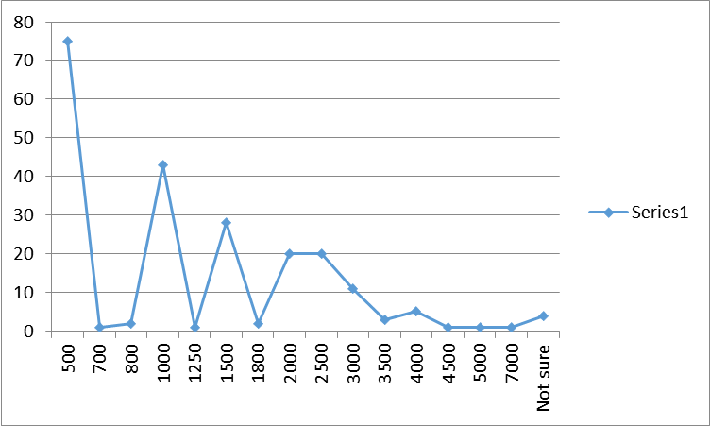
Other than this about 91% of the total workers have reported receiving no help whatsoever from the organization other than the govt by the end of the second phase of lockdown. These figures clearly state the distress situation of migrant workers who are completely left on the mercy of others to sustain.
Borrowings by the migrant workers for the essentials needs
In the absence of adequate support migrant workers are forced to borrow from other people in cash or kind to meet their daily needs. In the present study, we have found that about 48% of the total workers have borrowed for their needs during the second phase of lockdown.

When it is investigated further it was noticed that of the total worker who has borrowed, about 59% of them have borrowed the number of rupees between 600-3000, 9% borrowed between 4000-5000 and 6% borrowed more than 9000 rupees. However, the impact of lockdown is very clearly visible as workers have not just lost their works but also getting into the trap of debt which will weaken the bargaining power of workers eventually.

The workers ran out of the resources and were pushed up on the path of starvation in the absence of meaningful support. As evident in the findings, the workers went through a severe financial crisis and have become susceptible to many survival insecurities that are yet to come.

Workers future strategy to deal with the current crisis
Our findings suggest that the migrant workers went through a very distressful condition and it does not seem to be ending soon. Additionally, the majority of circular migrant workers have not been able to receive adequate support also. However, under these circumstances, the workers had no options but to evolve their strategy to overcome this.
Workers want to return back to the city for work
The growth of urban migration was the result of distress in the agriculture sector. However back in the village, there are already no work opportunities available hence the workers returning to the village are finding it very hard to sustain there.
Workers strategy for the post-covid lockdown
Workers plan for the work | Responses | Percents
After the lockdown gets over | 98 | 23.3 | 69.3
After the markets are reopened | 85 | 20.2
Have not decided yet | 28 | 6.7
Others | 16 | 3.8
Will not go | 16 | 3.8
will stay home for a while and then go | 108 | 25.7
Will think about going to the city once the CORONA gets over | 69 | 16.4
Total | 420 | 100

In the present study, we have found that 69% of the total workers want to get back to the city to get their earlier work after the lockdown gets over or staying home for a while. It was also found in the survey that 83%workers who had a family size of 4-8 members per household are willing to return to the city. However larger the size of the family is, higher is the willingness to return to the city even when the danger of covid19 still prevails in the city.
Workers requirement for a safe return to the city
Req. To return back to the city | Responses | Percents
After the Corona gets vanished from the city | 45 | 11.7
Demands for a better work | 2 | 0.5
Others ( it includes the responses like, better transportation, have not decided yet, after getting the call from city, will work somewhere else, full wages on time, when other workers starts to go to city etc) | 16 | 4.2
Safety from corona | 5 | 1.3
We are helpless, thus we have to go eventually. we dont have any demands however | 16 | 4.2
We will demands first for a proper safety kits like mask, hand sanitizer and measures for the social distancing | 143 | 37.2
We will not take the family members along | 5 | 1.3
we will only ensure our safety by using mask , santizor, and maintaining social distance | 23 | 6.0
We will take care of our safety on our own | 94 | 24.5
Will demand a full social protection for the work | 6 | 1.6
Will go after the markets get reopened | 10 | 2.6
Will look for the work elsewhere after coming back to the hometown | 1 | 0.3
Will not go to the city at all | 9 | 2.3
Will wait for a while and then go | 9 | 2.3
Total | 384 | 100

However for the safe return to the city about 37% of the total worker's demands for the safety kits like a mask, sanitize-rs, gloves, etc, while 24% of the workers are in that bad position, they don’t want anything from the govt and thus claims to protect themselves on their own. These facts hint towards the deplorable conditions of migrant workers as they are left with no options but to go back to the cities again risking their lives in the absence of state support and access to regular work in the hometown.
Survival options until they return to the city
As it is seen the work opportunities in the worker's hometown are not enough available to accommodate the needs of the workers, hence they want to get back to the city again. But as the lockdown is not lifted completely it will take a while to get the things normal so they can come back to the cities.
Plan till workers return to the city
Workers preference | Responses | Percents
Casual work | 1 | 0.3
Farming | 23 | 7.1
No. we cant survive without returning | 17 | 5.2
Others (it includes the responses like by selling the grains of home, learn new work, will work in nearby village or whatever work I get here, by lending the money, will return when the contractor will call us, return to previous employer etc) | 21 | 6.5
Should get the work continuously at the local level along with safety | 6 | 1.9
Want to return to the city immediately | 52 | 16.0
Will look out for the work at local level like construction work or NREGA | 170 | 52.5
Will migrate for the short distance and short time for work | 28 | 8.6
will open small scale enterprises or shops | 6 | 1.9
Total | 324 | 100

When the workers were asked about their plan of work until they return to the city, it was reported that about 52% of workers want to work on the local level while 16% of them claim to return to the city immediately for work.
Further on being asked about the types of work workers wants to until they return to the city, it was reported that about 38% workers are willing to work at the locally available work on local wages, 20% workers want NREGA work and 17% workers were ready to go the nearby villages for the work. Additionally, on the matter of wage expectation, about 37%workers expect a wage rate of rupees 300-400, 31% of workers expect a rate of rupees 300-400 and the rest expects different amounts.
What kind of work you want to look for in the village
Types of work workers wants to do | Responses | Percents
Agricultural work | 3 | 1.1
Any work could be made available nearby home | 50 | 17.7
Applicable minimum wage rate | 3 | 1.1
Construction work | 2 | 0.7
Have not thought of yet | 10 | 3.5
Local work should be made available | 109 | 38.5
NREGA | 57 | 20.1
Others( It includes the responses like safe work, construction work or centing, head loading ,office related work, work at the shop etc) | 10 | 3.5
Self employment or small scale enterprises should be supported | 9 | 3.2
Skilled work should made available | 30 | 10.6
Total | 283 | 100

Thus the workers in their hometown are running out of options to sustain in the absence of adequate state support and regular works and thus they are forced to take any work even if it comes with a risk of infecting covid19.

Workers prefer to rely on the support of their social network more than the govt
Due to the sudden lockdown and the informal nature of the work, migrant workers have got into a very distressful situation. However, they have evolved many strategies to fight with it though it is not a long term solution. On being asked about the support that the workers are seeking from to deal with the current situation, about 45% of the workers have reported being dependent on their social networks such as family members, relatives, friends, etc. The other 26% and 7% of workers are keeping their hopes on the Gram Panchayat and the welfare organization respectively to overcome the current situation. The current figures reflect the perception of the workers in the distress situation to seek out support and their trust especially towards the govt at the critical time.
Workers suggestion to deal with this emergency situation
Workers preference for support | Responses | percents
Need the support from Panchayat and govt. | 51 | 26.3
Need the support from the welfare organization | 14 | 7.2
Others(It includes responses like, not sure it, any work will do,should get good wages etc) | 5 | 2.6
Provide skill based training and support in the new work | 14 | 7.2
Should get the work in village only | 8 | 4.1
Support in the farming | 10 | 5.2
This work is not better. ( fear of getting silicos) | 3 | 1.5
Will engage with the old friends , relatives and people from village for work | 89 | 45.9
Total | 194 | 100

Support and assistance sought by the workers
Our findings have indicated that workers have not many options available left in their home town and they want to get back to the city on the re-opening of the lockdown. In the meanwhile time, they want to learn some new skills so they can have more options for livelihood and can face the distress situation better. In our findings it came out that about 28% of the total workers want to take different skills-based training, 9% wanted help in starting the self-employment, 5% sought support for farming, and rest others.
Support required from the workers side
Support sought by the workers | Responses | Percents
Financial and loan support for establishing self employment | 25 | 9.7
Others ( it includes the responses like , family condition is miserable and need support for that, not mentioned , support in finding NREGA, well off family,not decided yet, under debt, un-employed due to lockdown, support in finding regular % safe work, need ration support etc) | 96 | 37.4
Provide skills based training for a new work | 72 | 28.0
Support for doing farming in the village | 15 | 5.8
support for opening a new shop | 2 | 0.8
Support in finding a new regular work nearby with full safety | 37 | 14.4
Support in finding a work based on our skills | 4 | 1.6
Support in getting a NREGA work | 6 | 2.3
Total | 257 | 100

On the further investigation, it was found that in the category of other on being asked about the need of support which constitutes for about 37% of the total worker's responses, about 33% of the workers under the category of others report to have their family condition very miserable and they immediately need support for that. The situation of migrant workers are however very distressful and are crying out loud for support whoever can provide them at this critical juncture.

Case studies
Thavra Ram 22 year old (ST) and Lokesh 20 yers old (ST) says : “Aaj hume paise pure mil jaate toh hum apne pariwar ko iss musibat ke samay khila pate.” ( If we would have received our due wages we would have been able to feed our family properly at this critical juncture)
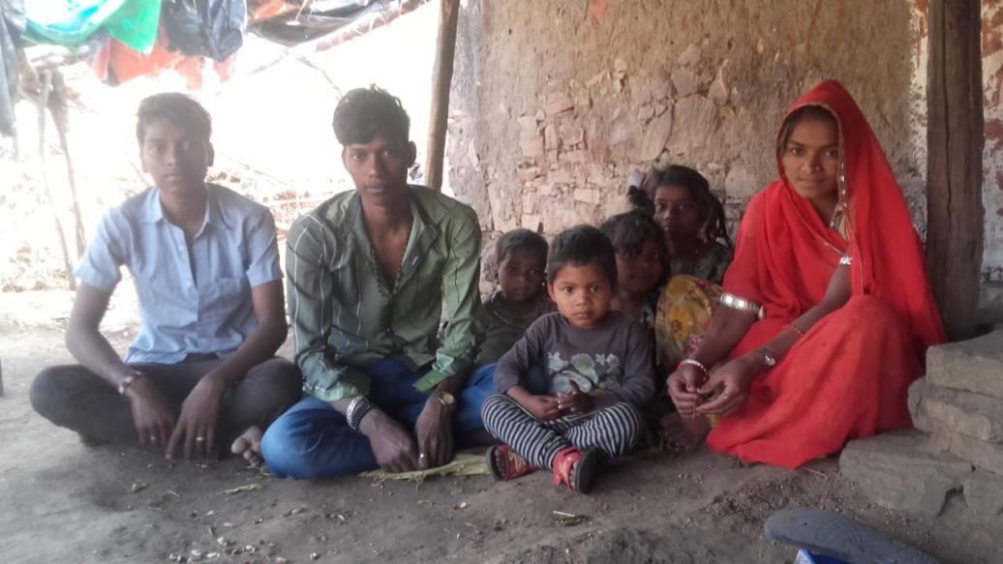
Thavra Ram and Lokesh Ram , two brothers are residents of Shiwadiya village, Dadiya Panchayat of Gogunda block in Udaipur district. Both of them work in Rasoi work in Morbi district of Gujarat. Thavra Ram works as a helper in the kitchen in a company.
For the last 6 months, he has been working on the monthly salary of 6000 rupees only which is also not given to him regularly. He was given money for the expenses but not a wage. From 20/8/19 till 28/3/20 he worked in the company as a helper and the employer did not give him his wages from the last 7 months. Due to wages for the work done is 36500. Similarly, Lokesh worked in a hostel before lockdown. From the last 7 months and 15 days, he has worked in the hostel for 4000 rupees only a month which was also not given regularly. Due to wages for the work done is 25000.
When they came to know about the lockdown, they got scared and they decided to come back to their family. They got scared about the spreading news of the virus and decided to start for their village. Walking some kilometers and taking the bus they could reach their village.
In the village, They are about a total of 11 members in the family and they returned without any money. The family is dependent on Ration through PDS which only provides wheat. For survival in these times, they cut down on the number of times they ate, have stopped having tea, cutting down on Vegetable intake.
The family has one job card, which does not have their names in it. Also in Shiwadia families are not supported by NREGA work. Family is just doing subsistence farming dependent on rainfall. Thavra and Lokesh have registered their complaints at the labor line. They want support regarding their wages and if they can get any work to get some wages.

Kanna Ram 32 years old (ST) : “Jab tak wahan sab safety nhi hogi tab tak mein nhi jaunga.” (Will not return until it gets safe there)
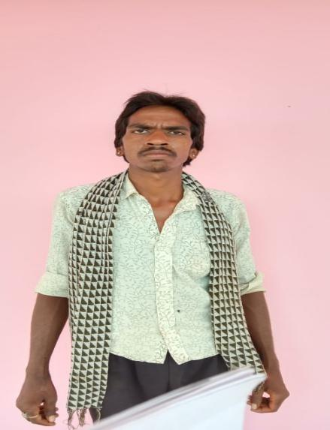
Kana ram is 32-year-old lives in Palasma , Sayar in Udaipur district. He works in Surat in a saree cutting thread to run his family. His wages for the month are 9000 but do not get this on a regular monthly basis. He with his one other friend has taken a room on rent in surat for 3000 rupees and both of them bare their expense of ration, water, electricity, etc.
Some months ago Kana Ram has taken advance money from his contractor around 25000 for the construction of his house in the village. So he was not getting his wages for 3-4 months but only taking 3000 rupees for the expenses. He still has 10000 to repay his contractor. When lockdown happened he was in surat. He was asked to leave and also he got scared about the news of virus spreading. But as he asked for the wages for the month, his contractor explained to him about his advance money. He gave him 2000 to reach his home.
Kana Ram with his friend started walking on 25th March. After walking 250 Km till Ratanpur border he got a lift from some pick up for some km, they walked again and took a lift till Udaipur. From Udaipur, they walked another 100km to reach their village on 27th March evening. On the way, they were able to get cooked food by some volunteer groups.
But his difficulties did not end here. He was left with only 200 rupees when he reached home. He has a family of 4 people with 2 children. They do not have their Ration included in NFSA so they do not get ration from the PDS. They do not have a Job card so they cannot work in NREGA which was the only option.
He is not included in any of the relief measures (cash transfers) announced by the Government. He got checked his wife’s account as he heard about the cash transfer but nothing was transferred. For the survival of his family, he has borrowed money around 3000-5000 from some friends and has also borrowed ration of 2000 on the ration shops. In initial time ration shops also did not give them ration without cash but sometimes they let them borrow. But for this, they have to give some cash amount of the total bill which he arranges from his friends and family. He borrows 20kg wheat 3 times till now from a family in the village.
He and his family is surviving on borrowed money and ration. Kana ram says he is ready to work whatever he will get in the village till the time he can go back. He said the contractor is calling him to come back. But he says he will only go if there is proper transportation, safety at the workplace because whenever he thinks about how he came back it frightens him a lot. He demands from the government to help him access ration from PDS which will support his family.

Chunilal/ Bhaga Ram is 50-year-old stone worker from Sibera a stone unit in Pindwara.The only source of income for the family is labor work. He further says that he has been sitting without work since the lockdown imposed in the country.
Even though he is a regular employee did not receive the salary of April and May.
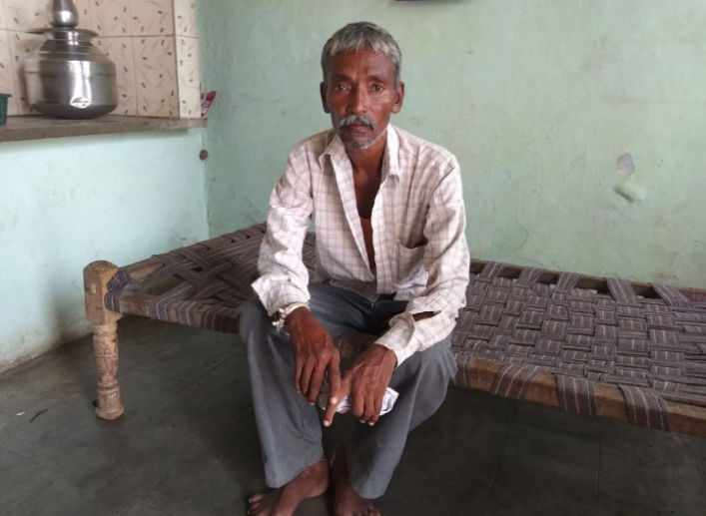
The family condition has become worsen and facing many difficulties to run the family for the last two and a half months he has no work. He is looking forward to the work but the factory is not in operation to date.
The problem is taking care of foods for the family as he has to support a 6 member family. he claimed that he earns only 8000 per month too difficult to save some money at the end of the month again three months joblessness has taken the family into the debt trap. Even though the government-supported for only 2500 to the families was not enough to meet the basic needs of the 6 members families. So it has impacted his calory intake in lockdown due to cash crisis he reported only very basic food item is available there is no vegetable, milk and other nutritious food in his basket.
He thanked god there are no health issues of any one of his families in this crisis or else it would have been more precarious for the family. He is concern about the normality of the situation and suspicious of a regular flow of income due to the spread of the coronavirus.
Like the previous workers, he also wants cash support from the government for the next two months as it seems difficult to go back to work and extension of an extension of working days in NREGA for more than 200 days this year for every needy family.

Durga Bai 28 year old (ST) “ Kuch bhi hojae apne gujare dino yaad karte , mein kabhi surat wapis nhi jaungi .” ( cant think of those horrendous days in Surat, I will never go back to surat again)
Durga Bai with her husband Hamera ram and 2 children one 4 months old and 4 years old lives in Surat. Her Husband works in Saree cutting trade for 7-8000 rupees for a month. He does not get his wages on a regular monthly basis. They are from the village Semad, Sayara in Udaipur district.
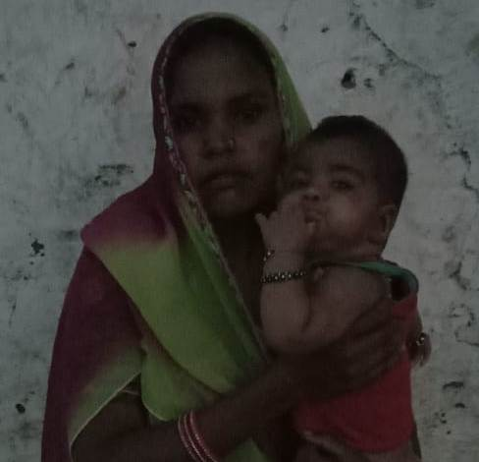
Unaware about the sudden lockdown, Hamera ram and his brother went back to the village on his uncle’s death on 20th March thinking they would return In 2-3 days. Before leaving he has given 3000 rupees to Durga Bai. In 4 days Lockdown was announced. Durga bai with her 2 children was stuck in surat alone. She said “ Bohot dar lag Raha tha, kya bimari hai , inte chote bacche hai kya karungi akele.” ( was very scared of the disease, how I will manage in this situation with these small kids here) . With some support from others from their village in Surat, she managed to get some ration, milk, etc for the children and herself.
After 5-6 days of lockdown, she decided to leave for the village with her children with other families. But after walking some 60 km the police forced them to return. Without getting any help everyone was forced to return to surat. After that incident, she got scared and did not want to walk back.
She stayed in Surat for 40 days. She had spent all the 3000 rupees which she had earlier. She managed to borrow some money and ration from other families. There were some days she did not eat and only were only able to feed her children. Some or almost many days she could manage to cook once in a day. She had spent sleepless nights thinking about how will she manage to go, how she will manage basic food for her children. She faces many difficulties and struggles during this period. She hardly got any help from the government. No ration, no cash transfers, no help.
After 40 days finally they , managed to travel in a truck with other from sayar in Surat and came back to their own village.

“Abhi kamai ka koi bharosa nenhi kab kaam milega, udhar bhi karunga to kese chukaunga, isiliye sirf khane gujar hojae to chalega” ( Right now there is no surety of getting work, if I borrow money how I will repay, hence just want to survive somehow right now)
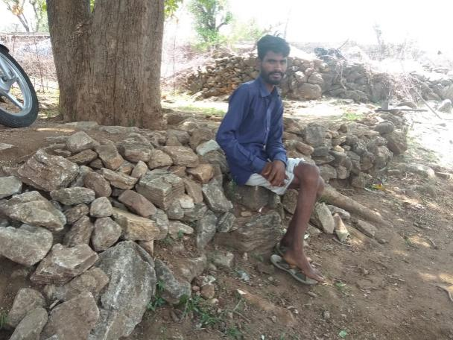
Hera ram / Kasna ji : Hera ram is a stone worker of Varli panchayat of Pindwara block. He is 30 years old and has been working as a stone artisan for 13 years. Even though Pindwara is a stone hub of providing employment opportunities to more than 10,000 workers a significant chunk of the workforce depends on outside Pindwara to sustain their livelihood. He earns 500 to 600 per day through the stonework.
Before lockdown, he was working in Amabji, Gujarat in a stone unit as a daily wage worker. He was getting 500 rupees per day and had been working in Ambaji for 5 months. He came to his village for celebrating Holi and after that nation-wide lockdown declared, since then he is sitting idle without any work. he has been waiting for the situation to get normal to go back to the work again.
He reported that he had 20,000 in his hand when he came to his village in March, he is now empty pocket spent all his money saved in the month of March and April. Since Month May he has been cutting his expenditure to manage his life only spending on the essential item to only for surviving. He told “Abhi kamai ka koi bharosa nenhi kab kaam milega udhar bhi karunga to kese chukaunga isiliye sirf khane gujar hojae to chalega” ( there is no certainty when I will go back to work when the situation will normal, how can I repay the debt if I borrow from others so only thinking about managing our food needs).
He is having difficulty in managing basic foods and vegetables and has stopped purchasing vegetables and fruits, milk, and other masalas due to an acute shortage of cash. The situation has become more worst for 10 to 15 days, as he has spent all the saved money of his and other 3000 support from the government.
To mitigate the cash risk MGNREGS support has a great contribution and he said my wife is going to work regularly since 20 days and work is available if she will get the money of her work it would be a great relief for the family as it comes as cash in our hand to adequately meet our food needs.
He expects from the govt additional cash support from the government for the next two months as it seems difficult to go back to work and extension of working days in NREGA for more than 200 days this year for every needy family.

Conclusion
The current crisis of migrant workers brings forth the existing architecture of our cities, promoted as the model of development and “an engine of growth”. This model of the city draws a clear line between the privileged and under-privilege, informal and formal workers, informal residents, and formal residents. However, under the current model, the city uses the labor of migrant workers and sheds it on the peripheries after its use. As the country is in the rapid transit mood of getting urbanized the workers especially the migrant workers on whose labor it sustains are not rightfully included in its architecture. However, the foundation of our current cities is built on the faulty line which draws a deep line of inequality against the mandate of the worker's right and Indian constitution.
Making a note of this, let us come back to the present study, which produces the evidence for the underlined argument. The present study shows that the lack of employer and state support has left workers to rely on informal and social networks for support- which has been inadequate and unreliable for them to meet basic needs. As work opportunities continue to be in a frozen state even after the lockdown has moved to the phases of unlocking the workers are still facing several problems related to their basic needs.
However it becomes very important for the government to must focus on creating cities that are inclusive of migrants - ensuring social protection and basic public provisioning to workers, on rural employment creation and social protection coverage that reduces distress migration in very terrible conditions as in the case of 69 percent workers who reported that they want to return, as well as strengthening the implementation of labour protection standards to ensure adequate wages and safe and dignified work conditions rather than the suspension of labour laws.
It has fortunately or un-fortunately received wide attention under the unexpected shock of the pandemic. However, this is the high time to underline the fault in the foundation of the city’s architecture existing for decades. Taking the current migrant crisis as a learning point the guiding principles of the city and its development therefore must be re-conceptualized and bring forth the necessary changes to avoid such kind of crisis in the future.

Bibliography
67 lakh migrants return to 116 dists in 6 states | India News,The Indian Express. (June 2020). Retrieved September 28, 2020, from https://indianexpress.com/article/india/coronavirus-lockdown-67-lakh-migrants-return-to-116-dists-in-6-states-6453084/

Covid-19 Crisis Exposes India’s Neglect of Informal Workers. (2020, May 12). NewsClick. https://www.newsclick.in/Covid-19-Crisis-Exposes-India-Neglect-Informal-Workers

COVID-19 Lockdown: Protecting the Poor Means Keeping the Indian Economy Afloat | Economic and Political Weekly. (April 2020). Retrieved September 28, 2020, from https://www.epw.in/engage/article/covid-19-lockdown-protecting-poor-means-keeping-indian-economy-afloat

Desai, D. R. (May 2020). Living at Worksites: Policy and Governance for Migrant Worker Housing in Ahmedabad’s Construction Sector. 157.

Deshingkar, P., & Akter, S. (2009). Migration and Human Development in India. 90.

Employment in informal sector and condition of informal employment. (2013-14). Retrieved September 28, 2020, from https://labour.gov.in/sites/default/files/Report%20vol%204%20final.pdf

Survival and Mobility in the Midst of a Pandemic. (April 2020). Economic and Political Weekly, 55(14), 7–8.

SWAN-To leave or not to leave? (June 2020). Retrieved September 28, 2020, from http://strandedworkers.in/wp-content/uploads/2020/06/SWAN-Report05062020-1.pdf

Annexure
1 The list of Workers destination for work
List of work destinations for migrant workers
SN | Name of the place | Frequency | SN | Name of the place | Frequency
1 | Aaspur | 1 | 40 | Lunavada | 2
2 | Aburoad | 4 | 41 | M.P | 1
3 | Ahmedabad | 102 | 42 | Maharashra | 1
4 | Ameth | 11 | 43 | Malari | 1
5 | Anand | 1 | 44 | Malva Nimach | 1
6 | Aspur, Dungarpur | 3 | 45 | Mandsor | 3
7 | Badisadri , Chitorgadh | 1 | 46 | Mehsana | 2
8 | Banswada | 1 | 47 | Mesana | 1
9 | Baroda | 10 | 48 | Sabala | 9
10 | Banglore | 5 | 49 | Modasa | 1
11 | Bharatpur | 1 | 50 | Morbi | 3
12 | Bhawnagar | 1 | 51 | Mount Abu | 1
13 | Bhilwara | 1 | 52 | mumbai | 11
14 | Bhuj | 3 | 53 | Nathadwara | 1
15 | Bombay | 1 | 54 | nithauva | 1
16 | Chittodgadh | 4 | 55 | paloda | 1
17 | Daily commuter | 1 | 56 | Partapur | 2
18 | Dwarka | 1 | 57 | Phalna | 3
19 | Gandhinagar | 1 | 58 | Pindwara | 49
20 | Gangapur | 2 | 59 | Pipalkhut | 3
21 | garhi | 1 | 60 | Pratapgarh | 1
22 | Ghatol | 1 | 61 | Rajkot | 9
23 | Goa | 1 | 62 | Rajsamand | 2
24 | Gogunda | 4 | 63 | sadri | 7
25 | Gujarat | 1 | 64 | sagwara | 1
26 | Himmatnagar | 2 | 65 | Sidhhpur/Patan | 1
27 | Indore | 4 | 66 | Sukher | 4
28 | Jaipur | 1 | 67 | Sumerpur | 2
29 | Jamnagar | 2 | 68 | Surat | 60
30 | Jhalawad | 1 | 69 | Suvasra,Mansor | 1
31 | jodhpur | 1 | 70 | Tonk | 2
32 | Junagarh | 2 | 71 | udaipur | 25
33 | Kalol | 1 | 72 | Umer Nagpur | 1
34 | Kankroli | 2 | 73 | Unjha | 4
35 | Kanthal | 1 | 74 | Ussar | 1
36 | KanyaKumari | 2 | 75 | vadodara | 1
37 | Katiyavad | 1 | 76 | Vapi | 1
38 | Kelwa | 6 | 77 | Vijaynagar | 1
39 | Kota | 2 | 78 | local | 14
 | ST. | 191 |  | ST. | 235
 | Total |  |  |  | 426

2 Help received by the workers from the organization other than the govt.

3 Borrowing of the workers in comparison with their access to the PDS ration

4 wage due to the workers among the daily wagers and the workers who receives the payment after the completion of every month

5 Workers cut down in the household expenditure in comparison with the total working members in the family
The cut down in the total household expenditure by total family size
Total Family members | Cut-down in the households expenditure | Cut-down in the households expenditure(%)
1 to 3 | 30 | 8.8
4 to 8 | 285 | 83.6
9 to 15 | 26 | 7.6
Total | 341 | 100

6 The incidents of emergency in then lives of workers during the lockdown period and the support received from the govt

