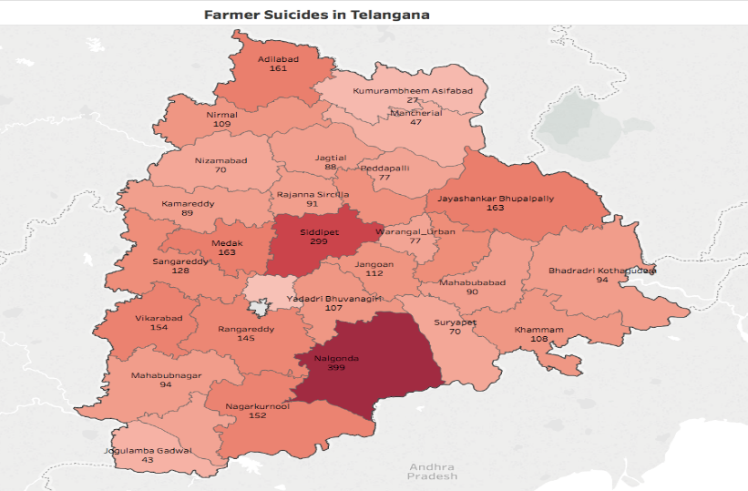

A Field Study report by Rythu Swarajya Vedika and students of Tata Institute of Social Sciences, Hyderabad, May-June 2018

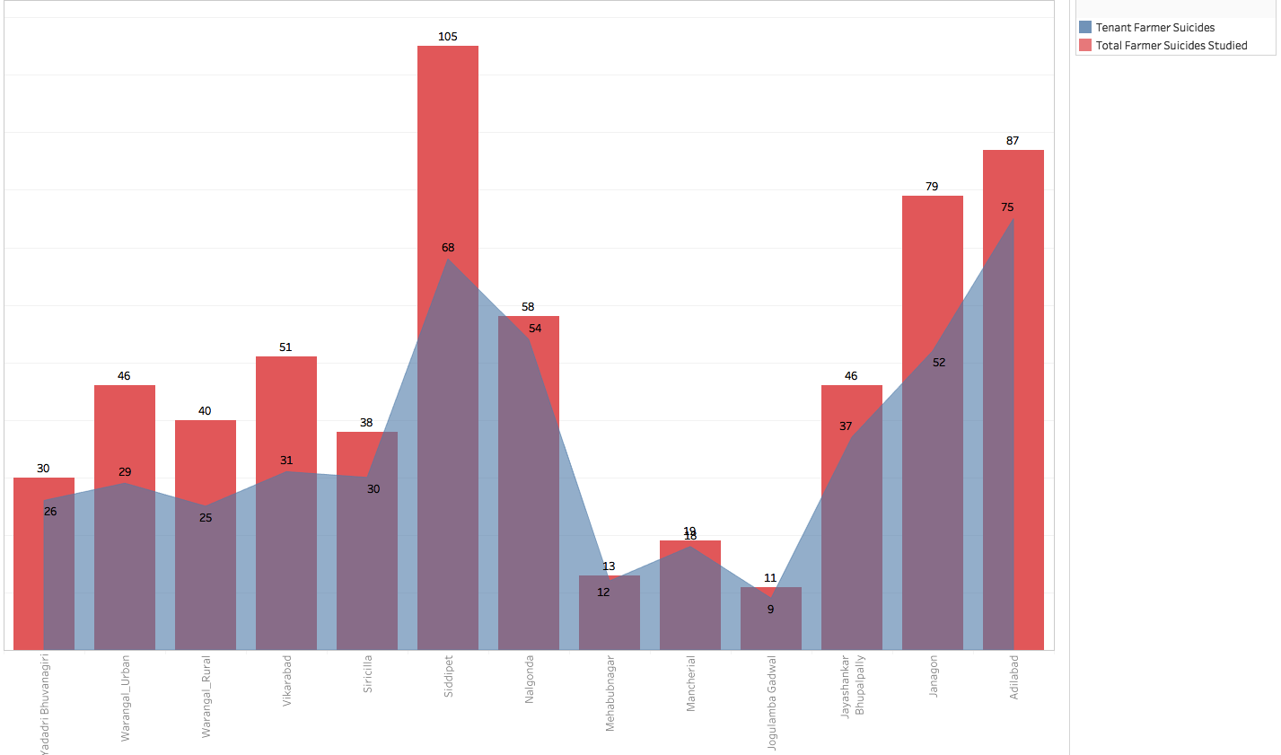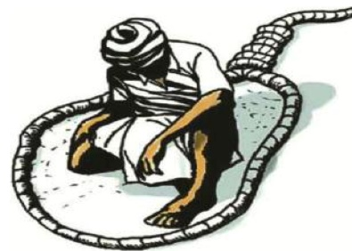

**Proportion of Tenant Farmers among the farmer suicides in the study:**

Of the 692 farmer suicides studied, 520 were committed by tenant farmers i.e. 75.14%.

Farmer Suicides, Land Ownership, Tenant Farmers & Rythu Bandhu

**Contributors to the Study**

**Students of Tata Institute of Social Sciences, Hyderabad and Azim Premji University:**

**TISS:** Naresh PJ, Vinathi Gurijala, Adil Akram, Gaddala Suresh, Nikhil Kumar, Varun Namineni,

**Azim Premji:** Adepu Madhukar

**Rythu Swarajya Vedika Team**

Divya Veluguri, B. Kondal, Naveen Ramisetti, Sreeharsha, Beeram Ramulu, Potharaju Isthari, Shilamathi Ramu, Mukka Ilaiah, Sangepu Borranna, Praveen Andey, Laxmi, Selush Ajay, PR Kiran, G.V. Ramanjaneyulu, Ravi Kanneganti, Kirankumar Vissa

**Other Professionals who volunteered for the study**

Shruthi Laya, Karthik Ram, Aparna Deshpande, Anirudh, Mekala Srinivas, Aditi Maddali, Shravya Mallavarapu.

**Participation from other organizations**

Dr. Tirupataiah (Human Rights Forum), Pruthviraj (Manjeera Raitu Sangham), Mallikarjun Pollineni and Suresh Ediga (i4Farmers, AID)

**Analysis done by:** Naveen Ramisetti, Naresh P.J., Kirankumar Vissa

***For more information, contact:***

Kirankumar Vissa: 9701705743, [kiranvissa@gmail.com](mailto:kiranvissa@gmail.com)

Naveen Ramisetti: 9160309301, [naveen.ramisetty@gmail.com](mailto:naveen.ramisetty@gmail.com)

B. Kondal: 9948897734, [bkondalareddy@gmail.com](mailto:bkondalareddy@gmail.com)   
Ravi Kanneganti: 9912928422, [ravi@csa-india.org](mailto:ravi@csa-india.org)

***Study Report released on June 15, 2018 at Roundtable Meeting at Sundarayya Vigyana Kendram, Hyderabad, which was attended by senior farmer union leaders, political party leader, retired bureaucrats, social activists and members of farmer suicide families.***

**Farmer Suicides, Land Ownership, Tenant Farmers and Rythu Bandhu**

**A Field Study Report by Rythu Swarajya Vedika and students of Tata Institute of Social Sciences, Hyderabad during May-June 2018**

**Introduction**

Rythu Swarajya Vedika collaborated with a team of students from Tata Institute of Social Sciences, Hyderabad to conduct some important studies during May-June 2018. The topics are of immediate interest to farmers, farmers’ organizations, all well-wishers of farmers and the government too. The issues of farmers are on the front burner with farmers’ agitations on the rise across India. The Centre and most state governments as well as all political parties are feeling compelled to give high priority to resolving farmers’ problems and addressing the agrarian crisis.

Telangana stands second in the country in the number of farmer suicides in the past few years. So there is a special urgency to understand the nature of the crisis and address it accordingly. For several months now, the Rythu Bandhu (investment support) scheme and the land records purification have been the major activities from the government – both undertaken with a high degree of fanfare. In the process, a debate has been generated about whether the government support is reaching the farmers who need it the most. Particularly, there has been a lot of criticism about the government’s refusal to identify the tenant farmers who are cultivating the land on lease, and insistence on providing the Rythu Bandhu support of Rs.8000 per acre only to the land owners, irrespective of whether they are cultivating.

In this context, we have undertaken two kinds of studies in a short period to throw light on these issues. The first is a study of about 700 farmer suicide cases from the past 4 years – a very large sample, constituting 20% of the farmer suicides reported in Telangana since its formation – on a few key parameters such as land ownership, tenancy, amount of debt and source of debt.

The second study consists of a few specific villages where all tenant farmers are surveyed in the context of the Rythu Bandhu scheme. This provides valuable insights into the actual ground situation in the context of the ongoing debate about exclusion of tenant farmers from support schemes. It gives an opportunity to critically examine the government’s refusal to extend support to tenant farmers, its description of the tenant farmers as a minor issue in Telangana, and the claim that the support given to land owners will get transferred to the tenants by way of reduction in the lease amounts paid by the tenants.

**Part I: Farmer Suicides – Land Ownership and Tenancy**

**Background**In the past few years, Rythu Swarajya Vedika (RSV) has been working consistently on the issue of farmer suicides and has been tracking almost every report of farmer suicide in Telangana. In September 2015, a detailed study was done of 142 farmer suicide cases and the report released. The report presented useful information and observations, for example, that 75% of the farmers who committed suicide were farmers who leased land from others. Some of these statistics have been used widely by various analysts, farmer organizations and media. Since many more farm suicides have continued to happen and the farmers’ agitations have intensified, a study with a much larger sample has been undertaken to get more up-to-date information in the context of current debates.

**Study Sample and Method**

With a target of reaching out to about 1000 farmer suicide families, the telephone survey method was chosen. From the database of farmer suicides maintained by RSV and the personal visits made by RSV volunteers in various districts, a concerted effort was made to obtain telephone numbers of as many families as possible. Only the farmer suicides reported from June 2014 to the beginning of April 2018 were chosen. Phone numbers were obtained for 994 families and calls were made. Leaving out the cases where we failed to reach the families or obtain full information, we were able to successfully complete the survey and obtain complete information from 692 families. Thus the final sample size for the study is 692.

The cases studied cover 23 districts of Telangana. The distribution in various districts is shown in Table 2.

**Questionnaire**

Since the telephone survey method was used, the survey was limited to a small number of questions designed to obtain very specific answers. There were a couple of questions which were not answered by some of the respondents, so those answers are analyzed keeping that in view.

|  |  |
| --- | --- |
| 1 | Name of Farmer who committed suicide |
| 2 | Date of Death |
| 3 | Gender, Age and Caste |
| 4 | Extent of Own Land |
| 5 | Whether cultivating land on lease |
| 6 | Extent of Leased Land |
| 7 | Outstanding Bank Loan at the time of suicide |
| 8 | Outstanding Private Loan at the time of suicide |
| 9 | Source of Private Loan |
| 10 | Rate of Interest for private loan |
| 11 | Crops grown |

**MAJOR FINDINGS**

1. The correlation between land ownership and the farmer suicides is shown in the table below. 13.5% are landless, another 45% are marginal farmers and 34% are small farmers. On the whole 93% of the farmer suicides are by marginal and small farmers, and landless.

**TABLE 1: Farmer Suicides and Landholding Pattern**

|  |  |  |  |
| --- | --- | --- | --- |
| **Land Ownership** | **No. of Suicides** |  | **% of total suicides** |
| Landless | 93 |  | 13.5% |
| 0 - 1 acre | 115 |  | 16.6% |
| 1 - 2.5 acres | 198 |  | 28.6% |
| 2.5 - 5 acre | 236 |  | 34.1% |
| 5 – 10 acre | 40 |  | 5.8% |
| More than 10 acres | 9 |  | 1.3% |

1. Out of 692 farmers, 520 are tenant farmers, *i.e.,* farmers who had taken land on lease and cultivated it. **This means that 75.14% of the farmer suicides are by tenant or lessee farmers.** Out of this, 18% were totally landless. Another 46% were marginal land-holders. This means that 64% of the tenant farmers were holding less than 2.5 acres of land. Another 30% were small farmers, *i.e.,* holding between 2.5 and 5 acres of land. Therefore, 94% of the tenant farmers committing suicide are small and marginal farmers or landless.

In some districts, the percentage of tenant farmers committing suicide is much higher. For example, in Nalgonda district, which has seen the highest number of farmer suicides in the past 4 years, 93% of the suicides are of tenant farmers. It is 87% in Yadadri-Bhuvanagiri, 86% in Adilabad and 95% in Mancherial.

**TABLE 2: Farmer Suicides and Tenant Farmers**

|  |  |  |  |  |
| --- | --- | --- | --- | --- |
| **District** | **Old District** | **Farmer suicide Cases Studied** | **Tenant Farmers** | **Tenant Farmers %** |
| Adilabad | Adilabad | 87 | 75 | 86.21% |
| Mancherial | Adilabad | 19 | 18 | 94.74% |
| Nirmal | Adilabad | 9 | 7 | 77.78% |
| Karimnagar | Karimnagar | 13 | 11 | 84.62% |
| Siricilla | Karimnagar | 38 | 30 | 78.95% |
| Khammam | Khammam | 7 | 6 | 85.71% |
| Jogulamba Gadwal | Mahabubnagar | 11 | 9 | 81.82% |
| Mehabubnagar | Mahabubnagar | 13 | 12 | 92.31% |
| NagarKurnool | Mahabubnagar | 1 | 1 | 100.00% |
| Wanaparthy | Mahabubnagar | 13 | 8 | 61.54% |
| Sangareddy | Medak | 6 | 4 | 66.67% |
| Siddipet | Medak | 105 | 68 | 64.76% |
| Nalgonda | Nalgonda | 58 | 54 | 93.10% |
| Yadadri Bhuvanagiri | Nalgonda | 30 | 26 | 86.67% |
| Kamareddy | Nizamabad | 5 | 3 | 60.00% |
| Nizamabad | Nizamabad | 1 | 1 | 100.00% |
| Rangareddy | Rangareddy | 4 | 3 | 75.00% |
| Vikarabad | Rangareddy | 51 | 31 | 60.78% |
| Janagon | Warangal | 79 | 52 | 65.82% |
| Mahabubabad | Warangal | 10 | 10 | 100.00% |
| Warangal_Rural | Warangal | 40 | 25 | 62.50% |
| Warangal_Urban | Warangal | 46 | 29 | 63.04% |
| Jayashankar Bhupalpally | Warangal | 46 | 37 | 80.43% |
| **TOTAL** |  | **692** | **520** | **75.14%** |

1. It is important to note that all the landless who committed suicide were tenant farmers, *i.e.,* they had taken land on lease for cultivation. This is important in the context of the fact that the National Crime Records Bureau attempted to separate “agricultural workers” and “farmers” into different categories when releasing the data on Farmer suicides – which resulted in reduction in the numbers under the category of “farmer suicides”. However, our study shows that all the landless persons from the village who committed suicide had taken land on lease for cultivation, and hence were cultivators in the true sense who invested in agriculture and got into debt.
2. When we study the pattern of debt which pushed the tenant farmers into suicide, we find that the access to bank loans was very limited, especially among the marginal farmers and landless, and there was heavy dependency on private loans. On the whole, 265 out of the 520 tenant farmers who committed suicide reported no outstanding bank loans but an average of more than Rs.4 lakhs of private loans, so it was the pressure of private loans that led to suicides. This also means that they got no benefit from government measures such as loan waivers.

Among the landless, the average bank loan was only Rs.11,000 while the average outstanding private loan was Rs.3.64 lakhs. 75 out of 93 landless tenant farmers had zero bank loans. Similarly, in the category which owned between 0 and 1 acre, 55 out of 90 tenant farmers had zero bank loans. The average bank loan was Rs.38,000 while the average private loan was Rs.3.85 lakhs.

**TABLE 3: Tenant Farmer Suicides and Institutional Debt**

|  |  |  |  |  |
| --- | --- | --- | --- | --- |
| **Land Ownership** | **No. of Tenant Farmer Suicides** | **Average Outstanding Bank Loan** | **Average Outstanding Private Loan** | **Farmers with no bank loan** |
| Landless | 93 | ₹11,000 | ₹3,64,000 | 75 |
| 0 - 1 acre | 115 | ₹38,000 | ₹3,85,000 | 55 |
| 1 - 2.5 acres | 198 | ₹46,000 | ₹3,85,000 | 67 |
| 2.5 - 5 acre | 236 | ₹66,000 | ₹4,44,000 | 59 |
| 5 – 10 acre | 40 | ₹1,46,000 | ₹4,34,000 | 6 |
| > 10 acres | 6 | ₹1,40,000 | ₹8,05,000 | 3 |
| **TOTAL** | **520** | ₹**50,000** | ₹4,06,000 | **265** |

1. In terms of cropping pattern, 81.4% of the farm suicide families cultivated cotton. Many of them also cultivated multiple crops on different parts of their land. There were 36% paddy farmers and 32% maize farmers. Significantly, about 10% of the farmers committing suicide had cultivated red gram, which has seen increase in cultivation in the past couple of years but did not get the promised prices.
2. In terms of social category, the highest percentage of the farmer suicides were by Backward Caste farmers (61%) followed by SC (17%) and ST (11%).

**TABLE 4: Social Category of Farmers who committed suicide**

|  |  |  |
| --- | --- | --- |
| **Caste Category** | **No. of Suicides** | **% of total suicides** |
| Backward Caste | 410 | 61% |
| Scheduled Caste | 114 | 17% |
| Scheduled Tribe | 76 | 11.3% |
| Other Castes | 236 | 10.7% |
| Caste information not reported | 20 | 2.8% |

**Part II: Village Studies on Tenant Farmers and Rythu Bandhu**

**Background**

Recently, there has been intense debate triggered by the initiation of Rythu Bandhu scheme and the land records purification program about the question of who is the cultivator. Many farmers’ organizations and analysts have raised concerns about exclusion of lakhs of tenant farmers, adivasi *podu* cultivators and sada bainama holders from the government support systems. There has been a broad demand for the inclusion of real cultivators. The response of the government has been to say that they will not worry about identifying who is cultivating the lands, but provide support strictly to the land patta-holders only. The “Rythu Beema” life insurance scheme is also being extended to the land patta-holders only.

In this context, the government has also asserted that the presence of tenant farmers or lessee cultivators is very minor in Telangana, that the lease arrangements where they exist are short-term and vary year to year, that it is not possible for the government to identify such cultivators, and that the support given to the land patta-holders will be passed on to the tenant farmers in the form of reduction in the land rent and so on.

In this context, we have decided to test these assertions by taking a small number of villages and do a study of a large section of tenant farmers in each village conducting a direct survey.

**Study Sample and Method**

The study has been done in 3 villages – Pottipalli in Sadashivpet mandal in Sangareddy district, Itikyala in Laksettipeta mandal of Mancherial district and Gimma in Jainath mandal in Adilabad district. These are typical villages in their respective areas and not outliers in terms of the number of tenant farmers. Another village that was partially surveyed was Lakshmikantapuram village in Dantepalli mandal in Mancherial district.

In each village, a direct survey was conducted by interviewing a large number of tenant farmers. Our survey covered between 50% and 75% of the total tenant farmers in those villages. The general data about the landholdings and acreage was collected from the village revenue officials.

**Questionnaire**

|  |  |
| --- | --- |
| 1 | Name of Tenant Farmer |
| 2 | Gender, Age and Caste |
| 3 | Extent of Own Land |
| 4 | Extent of Leased Land |
| 5 | Survey number of leased land |
| 6 | Extent of dry land and wet land in leased land |
| 7 | Lease rent amount per acre |
| 8 | Crops grown |
| 9 | Output yield of last season’s crops |
| 10 | Name of the owner |
| 11 | Caste of owner |
| 12 | Where is the land owner residing? |
| 13 | Occupation of the land owner |
| 14 | How many years since you leased land from same owner? |
| 15 | Do you have a written Lease agreement? |
| 16 | Did the land owner receive Rythu Bandhu check? |
| 17 | Did you ask the owner to share the Rythu Bandhu benefit? |
| 18 | Did the owner share the Rythu Bandhu benefit with you? |
| 19 | Did the owner reduce land rent this season? |
| 20 | Did you apply for Loan Eligibility Card (LEC) in the past? |
| 21 | Did you get LEC in the past? |
| 22 | If you applied but did not get LEC what was the reason? |
| 23 | If you got LEC, did you get bank loan based on LEC? |
| 24 | If bank denied loan on LEC, what was the reason? |
| 25 | How much bank loan do you have now? |
| 26 | How much private loan? |
| 27 | Rate of interest of private loan |
| 28 | What is the source of private loan? |

**SOME TYPICAL CASES OF TENANT FARMERS**

Before presenting the detailed findings, it would be useful to share a couple of typical case studies of tenant farmers from these villages to give a clearer picture of the ground situation.

1. Baddineni Lakshmanna is a farmer who committed suicide on May 18, 2018. from Lakshmikantapur village in Dandepally mandal of Mancherial district. He owned 1 acre of land, and leased 4 acres of dry land from Mr.Venkataswamy. He has been a tenant farmer for the past 20 years. He has been leasing the current piece of land of 4 acres for the past 4 years since 2014 from the same owner. The land lease amount is Rs.10,000 per acre, paid in cash at the beginning of the season. For the past 2-3 years, he has been making losses and pleaded with the land owner to reduce the lease amount. But the land owner did not agree to reduce the rent.

Last season, he cultivated cotton on 4 acres of leased land but due to an attack of pink bollworm, the yield was lower than normal at 5 quintals per acre, giving him only 20 quintals of total production. He sold it at Rs.3800 per acre, giving him only Rs.19,000 per acre from the sale. His son informed us that his father lost at least Rs.6000 per acre on cotton. He grew paddy in his own land of 1 acre. Due to pest attack, he got only 10 bags or 7.5 quintals of production instead of 20-25 quintals normal production. He had a private loan of Rs.4 lakhs and bank loan of Rs.30,000. Due to pressure of the private creditors, he committed suicide.

1. Gudepu Ramulu is a resident of Pottipalli village in Sadashivpet mandal, Sangareddy district. He belongs to Golla community (BC), does not own any land, and leased 5 acres from Mohan Reddy who is an employee living in Hyderabad. He pays Rs.15,000 per acre as lease rent. He has been leasing the same land for the last 2 years and this is the third year. He cultivated cotton on 5 acres and got an average yield of 6 quintals per acre. Even at the highest price this season of Rs.4200 per quintal, his gross income from selling the crop is only Rs.25,200 per acre. Considering that the out of pocket cultivation costs are between Rs.15,000 and 20,000 per acre, in addition to Rs.15,000 as the land lease, the tenant farmer made a loss of between Rs.5000 to 10,000 per acre. This means a loss of up to Rs.50,000 for the entire 5 acres in one season.

Gudepu Ramulu does not have any bank loan, but has a private loan of Rs.2 lakhs at 24% per annum interest rate. He never applied for a Loan Eligibility Card (LEC), nor did the land owner share any benefit from his Rythu Bandhu check with the tenant farmer.

**VILLAGE SUMMARIES**

1. **Itikyala village, Mancherial district:** The village has 1904 acres of agricultural land with 947 pattadars. The land owning households are approximately 500. There are about 120 tenant farmers in the village. We surveyed 89 of them, out of which 26 were completely landless. The surveyed farmers had leased in 520 acres of land, and the total amount of leased land in the village is around 700 acres –which is about 37% of the entire agricultural land that belongs to the village.

The average lease amount was about Rs.10,600 whether it was dryland or wet land. 69 out of the 89 surveyed tenant farmers had been leasing the land from the same owner for the past 3 or more years. All the owners got Rythu Bandhu checks, but none of them passed on the benefit to the farmer or reduced the land rent. In 9 cases (10%), the owner increased the land rent this year, after receiving the Rythu Bandhu support!

1. **Pottipalli village, Sangareddy district:** The village has 1420 acres of agricultural land owned by 435 pattadars. The agricultural households in the village are about 300. There are about 125 tenant farmers who are leasing in land in the village. We surveyed 87 of them, out of which 10 were completely landless. The surveyed farmers had leased in 455 acres of land, and the total amount of leased land in the village is around 625 acres. This means that 44% of the entire land is being cultivated by tenant farmers!

The average lease amount was about Rs.14,100 with very little difference between dryland and wet land. 67 out of the 87 surveyed tenant farmers had been leasing the land from the same owner for the past 3 or more years. All the owners got Rythu Bandhu checks, but none of them passed on the benefit to the farmer or reduced the land rent. In one case, the owner increased the land rent this year, after receiving the Rythu Bandhu support!

**MAJOR FINDINGS FROM VILLAGE STUDIES**

1. **Not a minor issue – High extent of leasing:** In each village, between 25% to 40% of the households are tenant farmers who are leasing in land. In terms of land extent, between 30% and 44% of the total land is being cultivated by tenant farmers.
2. **Medium and Long term pattern of leasing:**

In contrast to the claim that the tenants on the land change every year, we found that the leasing pattern is relatively stable. 50.4% of the tenants have been leasing the land from the same owner for 3 to 5 years. Another 28.2% have been leasing the same land for more than 5 years, which indicates a long-term relationship. Only 21% have had it for 1-2 years. Therefore, it is very much possible for the government to recognize the lessee cultivators. This also indicates that this pattern of leasing has been happening over many years, and the land leasing is on the increase as shown by the government’s own Telangana Social Development Report.

**TABLE 5: Stability in the land leasing pattern**

|  |  |  |  |  |  |
| --- | --- | --- | --- | --- | --- |
|  | **Pottipalli** | **Itikyala** | **Gimma** | **Cumulative** | **Cumulative %** |
| Leasing same land for 1-2 year | 20 | 17 | 24 | 61 | 21.4% |
| Leasing same land for 3-5 years | 46 | 41 | 56 | 143 | 50.4% |
| Leasing same land for >5 years | 21 | 28 | 31 | 80 | 28.2% |

1. **Lease Rates and Acreage:** Out of a total of 292 tenant farmers surveyed in the three villages, 105 are landless. The average own land is 2.71 acres for each tenant farmers, and the average leased land is 5.82 acres. The average lease rate across the villages is Rs.11,519 per day.

**TABLE 5: Lease Rates and Acreage**

|  |  |  |  |  |  |  |
| --- | --- | --- | --- | --- | --- | --- |
| **Village Name** | **Total Surveyed** | **Avg. Own Land** | **Landless** | **Total Leased Acerage** | **Avg. Land Leased** | **Avg. Lease Rate** |
|
| Pottipalli | 87 | 2.33 | 10 | 455.5 | 5.24 | 14100.00 |
| Itikyala | 89 | 2.36 | 26 | 519.15 | 5.90 | 10647.13 |
| Gimma | 116 | 3.27 | 69 | 724.46 | 6.25 | 10252.59 |
| **Total** | **292** | **2.71** | **105** | **1699.11** | **5.82** | **11519.16** |

1. **Land Owners:** Only 15.5% of the land owners have Agriculture as their occupation. 50% of them are either Employees or Businesspersons. About 10% are old-aged while a large section are listed under “Other” which includes non-working persons, those whose occupation is not specified or those who have other occupations such as daily labour or stone masonry. About 60% of the land owners leasing out their lands are living outside the village.

**TABLE 6: Land Owner’s Occupation**

|  |  |  |  |  |  |
| --- | --- | --- | --- | --- | --- |
| **Village Name** | **Agriculture** | **Business** | **Employee** | **Old Aged** | **Others** |
|
| Pottipalli | 20 | 6 | 29 | 13 | 19 |
| Itikyala | 6 | 22 | 25 | 6 | 30 |
| Gimma | 15 | 20 | 29 | 6 | 18 |
| **Total** | 41 | 48 | 83 | 25 | 67 |

1. **No Reduction in Rent after Rythu Bandhu support:** One of the claims by the government was that the land owners who receive the Rythu Bandhu support would pass on at least some of it to the tenants, and that land rents are being reduced by Rs.2000 per acre.

However, our survey showed that in all the villages surveyed, **not a single land owner passed on some part of the support to the tenant or reduced the land rent.** In fact, in 10 cases, the land rent has been increased! Only 29 out of the 292 farmers even requested their owners to share the Rythu Bandhu support with them.

**TABLE 7: Rythu Bandhu and Loan Eligibility Cards (LEC)**

|  |  |  |  |  |  |
| --- | --- | --- | --- | --- | --- |
| **Village Name** | **Rent Reduced after Rythu Bandhu** | **Rent Increased after Rythu Bandhu** | **How many applied for LEC** | **How many received LEC** | **How many got loans on LEC** |
|
| Pottipalli | 0 | 1 | 15 | 13 | 0 |
| Itikyala | 0 | 9 | 5 | 4 | 0 |
| Gimma | 0 | 0 | 76 | 1 | 0 |
| **Total** | **0** | **10** | **96** | **18** | **0** |

1. **Not getting Loan Eligibility Cards (LEC):** Out of the 292 farmers, only 96 had applied for LEC card in the past and only 18 tenant farmers received LEC cards in the past. Out of this, not a single tenant farmer got a bank loans based on LEC cards. In the last couple of years, not a single LEC card has been issued. Most tenant farmers are not aware of the LEC cards. Despite the Land Licensed Cultivators Act (2011) being in operation, the implementation has been completely neglected.

**CONCLUSIONS**

The study of farmer suicide families shows that land ownership and access to land for cultivation plays a big causative role in agrarian distress. Tenant farmers are especially facing the brunt of the agrarian distress in Telangana. As per official figures, about 20.1% of landholdings in Telangana are being cultivated by tenant farmers. But their proportion in farmer suicides is remarkably higher at 75%. They face higher cultivation costs due to additional burden of lease amount, and do not get any government support systems. When the skew in distress and suicides is so clearly visible, it is an urgent requirement for the government to give high priority to reach out to the tenant farmers and include them in the government support systems.

The study also shows that the farmers are heavily dependent on private loans at high interest rates, pushing them further into the debt trap. Therefore, measures such as the massive loan waiver by the Telangana government did not reach the most distressed sections including tenant farmers and marginal farmers. It is imperative to ensure that the bank credit system reaches the marginal farmers and tenant cultivators, and implement a comprehensive Debt Relief system. Telangana has already adopted an Agricultural Debt Relief Act in 2015 on the lines of a similar Act in Kerala, but it hasn’t been implemented. It is high time to operationalize it after framing the rules.

Our village studies showed that the extent of land leasing is much larger than is being acknowledged – with 30-50% of the land in each village being cultivated by tenant farmers under lease. Many of the assertions of the government about tenancy have been found wrong in our study. We did not find a single case of reduction in land rent after Rythu Bandhu, and in fact, there have been increases in rent.

Therefore, the findings clearly show that the problem of identifying the tenant farmers and the real cultivators is of enormous importance and urgency. The government should implement the Licensed Cultivators Act 2011 and issue LEC cards, and ensure that bank loans and government support goes to them. If needed, improvements should be made in the 2011 Act or its rules, and issues related to earlier Acts dealing with Tenancy should be addressed, rather than making it completely non-operational.

The government should hold extensive consultations and find a solution to the problem of tenant or lessee farmers and identification of actual cultivators, rather than wishing away this enormous and urgent problem.