Nearly 50% of India’s working women are feeling increased stress due to the pandemic: LinkedIn Workforce Confidence Index
44% of working mothers are working outside business hours to provide childcare

India, September 10, 2020: LinkedIn, the world’s largest online professional network, today announced the findings of the tenth edition of the LinkedIn Workforce Confidence Index, a fortnightly pulse on the confidence of India’s workforce. Based on the survey responses of 2,254 professionals in India, findings from the weeks of July 27 - August 23 reveal the pandemic's impact on India's working mothers and working women, and the cautious optimism of freelancers towards personal finances and career prospects.

The tenth edition of the Workforce Confidence Index shows that India's overall confidence is growing steadily, with a composite score of +57 (up from +53 in the fortnight of July 13-26). The survey also reveals that the pandemic is taking a toll on the emotional well-being of India's working women as 47% report they are experiencing more stress or anxiety due to the pandemic. For men, this number stood at 38%, pointing towards a disproportionate impact on women in these testing times. The survey also underscores the challenges of childcare during the pandemic.

31% of working mothers are providing childcare full time, compared to 17% working fathers
Remote working has laid out a tougher road for India's working mothers as the survey shows that around 1 in 3 (31%) working mothers are currently providing childcare full-time, when compared to nearly 1 in 5 (17%) working fathers. Worryingly, more than 2 in 5 (44%) working moms are working outside their business hours to provide childcare, nearly twice as many men (25%).
Data also suggests that working mothers are more likely to bear the brunt of distractions from childcare while men seek support from friends and family. The survey shows that only 1 in 5 (20%) working mothers rely on a family member or friend to take care of their children, when compared to 32% men. Findings also show that more than 46% working mothers report working till late to make up for work, and 42% are unable to focus on work with their children at home.
Commenting on these parenting disparities, Neha Bagaria, CEO, JobsForHer says, "One factor is balancing office and domestic work - the bulk of the latter being shouldered by women. Studies reveal increased participation of men during the pandemic, but women still spend most time caring for children."

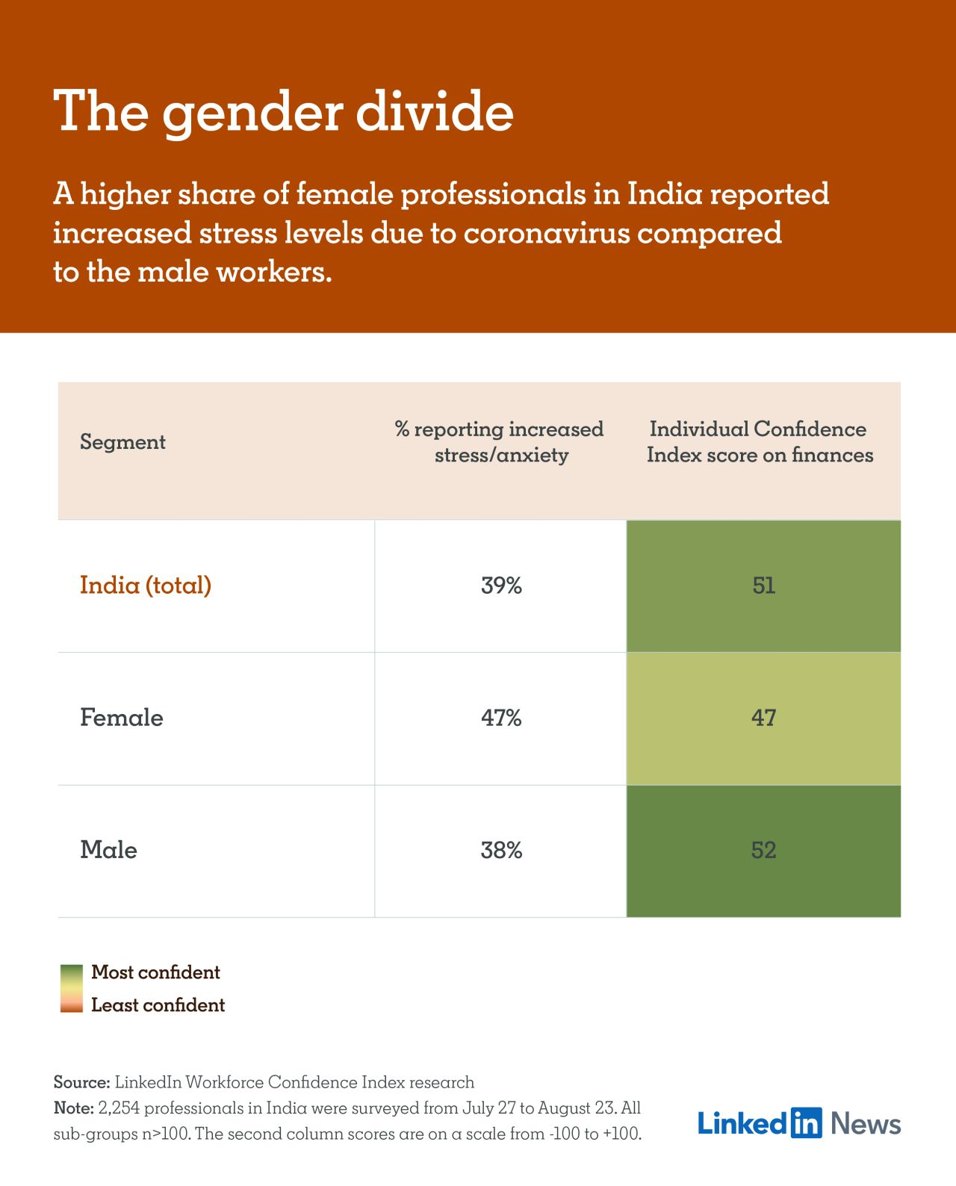

1 in 4 freelancers expect their earned income to increase in the next 6 months
As more companies explore the merits of having an alternative workforce in the present times, freelancers in India reported cautious optimism towards personal finances and career prospects with an overall individual confidence score of +46. Findings show that about 1 in 4 freelancers anticipate an increase in their earned income (25%) and personal savings (27%), while close to 1 in 3 (31%) expect their number of investments to increase in the next 6 months.
“The pandemic has accelerated the temporary worker economy, And this trend is likely to sustain in the short term for two reasons,” says Suraj Moraje, Group CEO of a staffing firm. “One, several employers are hesitant to take on the responsibility for new permanent employees as the demand outlook remains murky. And two, companies want to bring in specialised skill sets for a variety of roles,” he explains, thus reassuring freelancers of upcoming economic opportunities.
Check out the member commentary on this fortnight’s Workforce Confidence Index here.

###

Note to editors
About LinkedIn Workforce Confidence Index
The Workforce Confidence Index is a fortnightly pulse on the confidence of the Indian workforce. It is based on an online survey of 2,254 members (including 60+ female working parents and 100+ male working parents) across the weeks of July 27 to August 23, and uses a scale from -100 to +100 to reflect professionals’ current sentiments about the jobs market, their financial status, career progression, and their expectations going forward. It is a measure of how professionals feel about their job stability and access to opportunity as well as how business leaders expect to invest in their companies in the near and mid-term.

About LinkedIn
LinkedIn connects the world’s professionals to make them more productive and successful and transforms the way companies hire, market and sell. Our vision is to create economic opportunity for every member of the global workforce through the ongoing development of the world’s first Economic Graph. LinkedIn has more than 706 million members and has offices around the globe.

Media contact:

Bhairavi Jhaveri  LinkedIn  bjhaveri@linkedin.com  +919820273519 | Aditi Thakore  Current Global  athakore@currentglobal.com  +919769176117

###

